Proposed System Analysis and Modelling

INF20029 - Digital Business Analysis and Design

Team 8

Tung Nam Nguyen (103181157)

Le Minh Trung (103487499)

Nguyen Trong Gia Binh (103808278)

Vu Ngoc Vi (104093790)

# Executive Summary

This report presents the conceptual design and analysis for a Dental Clinic System, focusing primarily on patient administration. This system aims to streamline administrative tasks, such as managing patient records, tracking office visits, and handling invoices. It does not manage medical records, focusing instead on administrative data.

The stakeholders identified include patients, head of household, dentist and dental staff, receptionist, insurance companies, office business manager, IT team, dental clinic owner. Each stakeholder group has different interests and power levels influencing the system's design and functionalities.

The report also investigates the My Health Record system from Australia as a potential expansion for the Dental Clinic System. The My Health Record system provides comprehensive medical record keeping, but integrating it with the clinic's system could present challenges such as data privacy and data accuracy.

A range of use cases were identified, corresponding to various events related to patient administration. The system needs to respond to these events, which include creating, reading, updating, and deleting (CRUD) operations on patient, household, insurance carrier, dental staff, visit, procedure, and invoice data.

A domain model UML Class Diagram was developed to visually represent the system's classes, attributes, operations, and relationships, outlining the system's structure. This diagram helps identify the relationships, including associations, aggregations, and many-to-many relationships.

The report also proposes a state machine diagram for the insurance invoice object, showing the different states an invoice can go through and the transitions between these states.

An activity diagram, along with system sequence diagram is also developed, giving a better insight of the Dental Clinic Additionally, a storyboard for the Enter new patient is also proposed, which implements 5 design principles: usability, visibility, affordance, consistency and readability.

In conclusion, this report provides a comprehensive blueprint for the development of a Dental Clinic System. It identifies key stakeholders, potential challenges, and the necessary functionalities for successful implementation. Future work would involve addressing the identified limitations and preparing the system for practical deployment.

# **Table of Contents**

**Executive Summary 1**

**Table of Contents 2**

**Introduction 3**

**Task A: Research Questions and Basic Models 3**

**Task B: Advanced Modelling 13**

**Deployment Method 22**

**Conclusion 23**

**Reference 23**

# Introduction

The purpose of this business analysis report is to evaluate the current business structure of “Painless” Dental Clinic System, identify areas that require improvement, and propose new concepts and ideas to address these challenges. Building upon a previously designed and illustrated report, this analysis aims to showcase innovative solutions and recommendations for the new business design. Throughout the report, the emphasis is placed on customer-driven results as a top priority in developing these improvements. The recommendations aim to create a more efficient and customer-centric business model, ensuring that customer needs and preferences are at the forefront of decision-making. The proposed system should effectively manage patient administration, dental staff records, office visits, procedures performed, and invoicing for a clinic without storing any medical records. It streamlines the process of administering patient records, improves efficiency, and ensures accurate billing and invoicing practices.

# Task A: Research Questions and Basic Models

**Q1: Stakeholder analysis**

The stakeholder of the Dental Clinic can be:

**Patients:** Patients are the primary stakeholders in the dental clinic system. They want efficient, accurate, and convenient administration processes, such as scheduling appointments, managing their personal information, and receiving invoices. They are also interested in maintaining the privacy and security of their personal data. They are the stakeholders with moderate influence and significant interests in the system. Despite the fact that they may not have direct control over the system, their satisfaction and experience are crucial to the success of the dental clinic.

**Head of household:** They are responsible for coordinating the dental care of their family members and are frequently the primary point of contact for invoicing and insurance-related issues. Their interests include ensuring efficient and accurate administrative processes, receiving clear and timely invoices, and having access to relevant information about their family's dental care. Regarding the power and interest of this stakeholder, they have moderate power and high interest in the system. While they may not have a direct influence on the system, their satisfaction and experience with the administrative process are critical to the clinic's success, just like the patients.

**Dentists and dental staff:** They need to have access to accurate and up-to-date patient information, streamlined processes for entering dental procedure information, and efficient scheduling and administration of their workload. They are also interested in enhancing the quality of care they deliver and boosting patient satisfaction. They have high power and medium interest in the system as they perform dental procedures and interact directly with patients. They are interested in an easy-to-use system that streamlines administrative tasks, allowing them to focus on providing quality care.

**Receptionist:** They need an efficient system for managing patient data, scheduling appointments, and monitoring office visits. They are also interested in minimising errors and ensuring clear communication between the dental staff and patients. They have medium power and low interest in the system. Their role in patient administration and appointment scheduling is crucial, but they may not have a significant influence on the system. Addressing their need for efficiency and accuracy in handling patient information is crucial for smooth clinic operations.

**Office business manager**: They are responsible for maintaining dental staff information, printing invoices, and managing financial transactions. They are interested in a reliable and efficient system that provides accurate data collection and reporting to support their decision-making and administrative tasks. They have medium power and medium interest in the system, as they have some influence on it through their role in managing dental staff information and financial transactions.

**Insurance companies**: They are interested in receiving accurate and timely invoices, processing claims efficiently, and minimising the risk of fraud or errors in billing. They have medium power and medium interest in the system because they process claims and reimbursements, which can impact the clinic's financial stability.

**IT team:** They are responsible for the system's stability, security, and user support. They need a system that is easy to maintain, update, and adjust when needed. With regard to the power and interest of this stakeholder, they have high power and low interest in the system. They have the power to maintain and troubleshoot the system, but their interests may not be directly related to the system's core functionalities. It is crucial to involve them in the system development process and support their needs to ensure a stable and secure system.

**Dental clinic owner**: They have an interest in the overall efficiency, profitability, and reputation of the clinic. They want a system that streamlines administration, enhances patient experience, supports informed decision-making, and complies with industry regulations and standards. They have high power and high interest, as they have a significant influence on the decision-making process and are highly invested in the system's success. Addressing their interests and concerns is crucial for the system's overall efficiency, profitability, and reputation.

Here is the diagram summarising the power and interest of each stakeholder

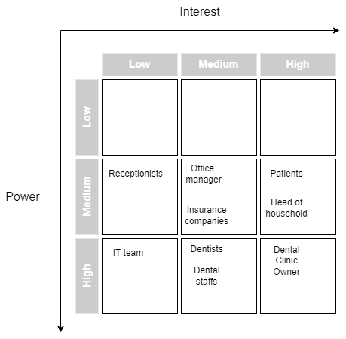

Below is the diagram summarising the type of each stakeholder

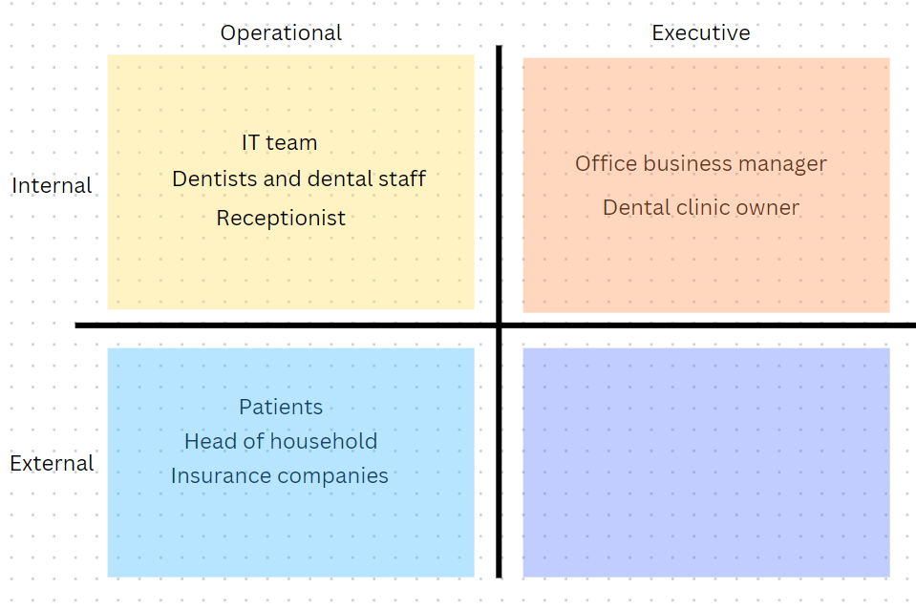

**Q2: My Health Record interactions**

My Health Record (MHR) is a national electronic medical record system introduced by the Australian government to provide a secure and easily accessible overview of an individual's health information. This system is designed to improve the quality, safety, and efficiency of healthcare services by enabling better communication and collaboration between the patients and the healthcare provider. My Health Record can store multiple type of information such as medical history, medication, allergies, and test results (Health Direct, 2019)

The current Dental Clinic System focuses on patient administration and does not maintain medical records. Therefore, if it expanded and integrated with the My Health Record system, dental professionals would have access to patients' medical histories and other important medical information. This integration would enhance the overall quality of care by reducing medical errors and unnecessary duplication of tests (Margo, 2018). In addition, dental professionals could upload dental records and treatment information to My Health Record, ensuring continuity of care across providers.

However, there are still some issues implementing My Health Record. First and foremost, the primary concerns are privacy and security. Health data is said to be one of the most favourite targets for hackers because it can be used to commit a variety of offences. They can use the victims' ID numbers, dates of birth, and other relevant information to obtain credit cards and loans. Medical information might also be used to impersonate patients to acquire expensive healthcare service and Medicare benefits (Journal, 2022). As a result, such data must be stored securely and protected by a highly advanced security system. In the case of My Health Record, the Australian government protects the data stored with a variety of security controls (Health Direct, 2019). Despite the assurances from the Governments, some users still worry about potential data breaches or unauthorised access to their medical records due to the fact that there have been instances of unauthorised access and data breaches in healthcare systems worldwide. A vivid illustration for this is the Community Health Systems Data Breach, which happened from April to June 2014. The hackers utilised the special malware to attack the system, resulting in the seizure of private patient data. Consequently, the incident affected over 4.5 million individuals who received care from a facility affiliated with the Community Health system network within the past five years (Kost, 2023). Furthermore, data accuracy is also a factor that should be considered. Since MHR relies on data input from the patients and some patients may even have limited digital literacy skills or face other barriers to access, such as language or cultural differences, there may be inconsistencies or inaccuracies in the records. According to the study (Wuerdeman et al., 2005), electronic health records are frequently incomplete and additional data should be required. As a result, this can pose a great deal of difficulty in medical data analysis and the treatment of patients. Last but not least, the adoption and usage of My Health Record in the current medical system can be a big problem. Although My Health Record is intended to facilitate communication between healthcare providers, its effectiveness relies on widespread adoption and compatible systems. Some healthcare providers are still not using MHR or face interoperability issues, which can diminish the benefits of the system. Not only that, in order to adopt the system, healthcare providers need to be properly trained and supported to use the technology effectively. This includes knowing how to access, interpret, and contribute to patient records while also assuring data privacy and security (Liaw & John Stirling Humphreys, 2006), which can be costly and time-consuming.

**Q3: CRUD Technique**

The CRUD (Create, Read, Update, and Delete) approach is a method for describing the fundamental data operations that a system should perform. In the context of the Dental Clinic System, the CRUD approach ensures that the system covers all the necessary data management and maintenance functionalities. As a result, here is a brief description of how CRUD technique should be used for the system:

1. Create: The system should be able to create new records for patients, dental staff, office visits, dental procedures, and invoices.
2. Read: The system should be able to read and retrieve existing data from the records. This includes viewing patient, dental staff, and office visit information, as well as generating reports such as the overdue invoice report and the dental staff performance report.
3. Update: The system should be able to update existing records when changes occur. This includes updating patient information, dental staff information, office visit details, dental procedures, and invoice information.
4. Delete: The Dental Clinic System might need to delete records in certain cases, such as when a patient is no longer receiving treatment at the clinic or when a dental staff member leaves the practice. Implementing the delete functionality ensures that the system can remove any unnecessary or outdated information.

Here is the table containing all the events, types of events and use cases:

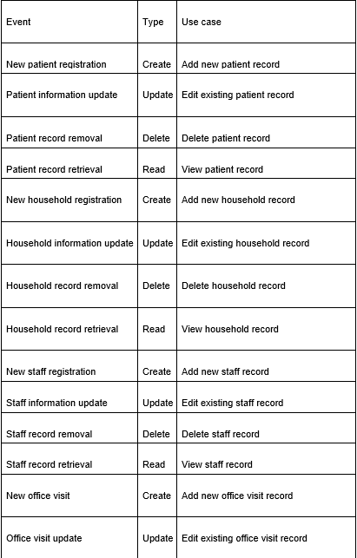

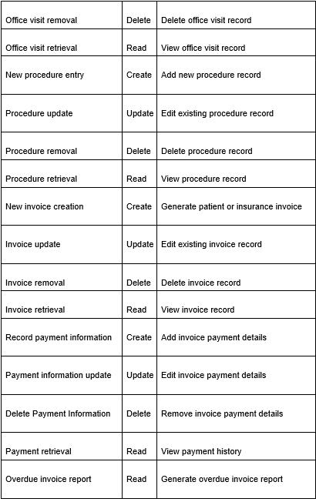



The table below shows the actors of the use cases

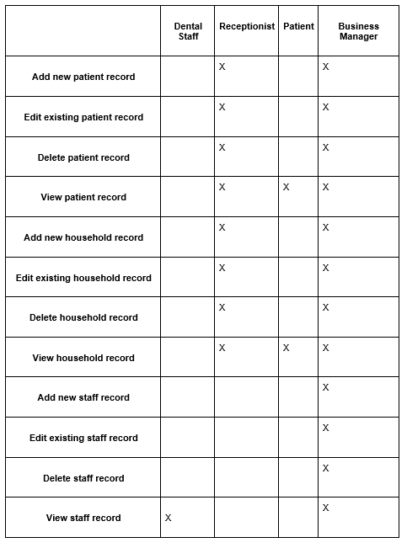

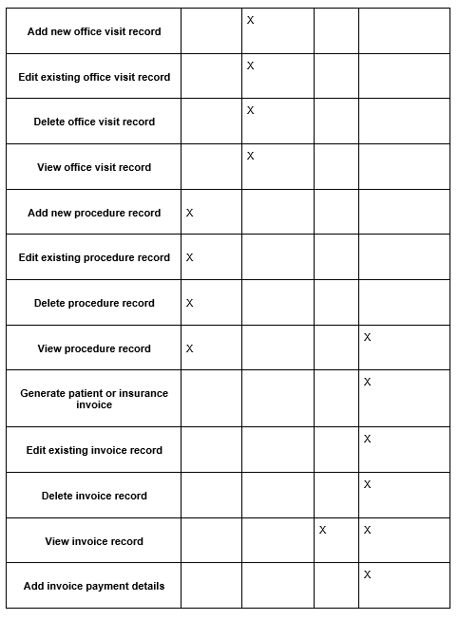

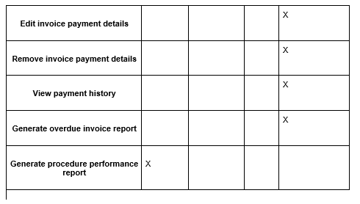

**Q4 Use Case Diagram**

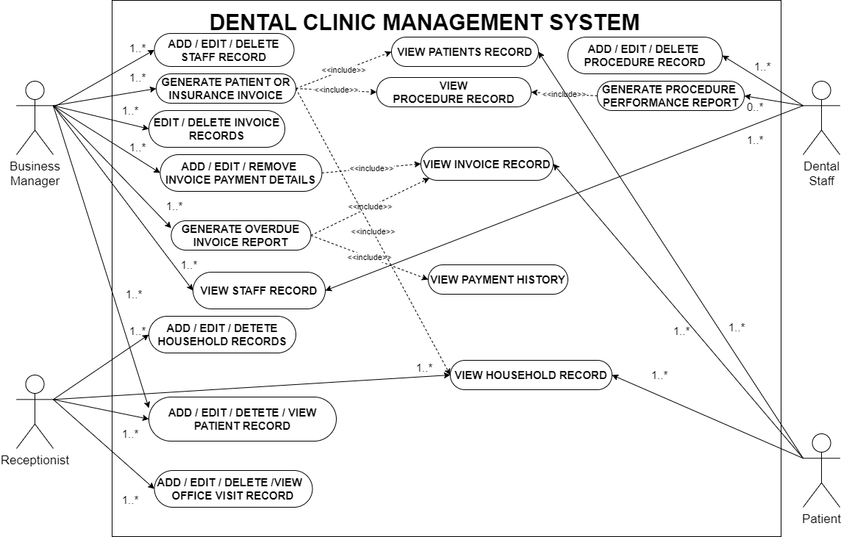

**Q5 Domain Model UML Class Diagram**

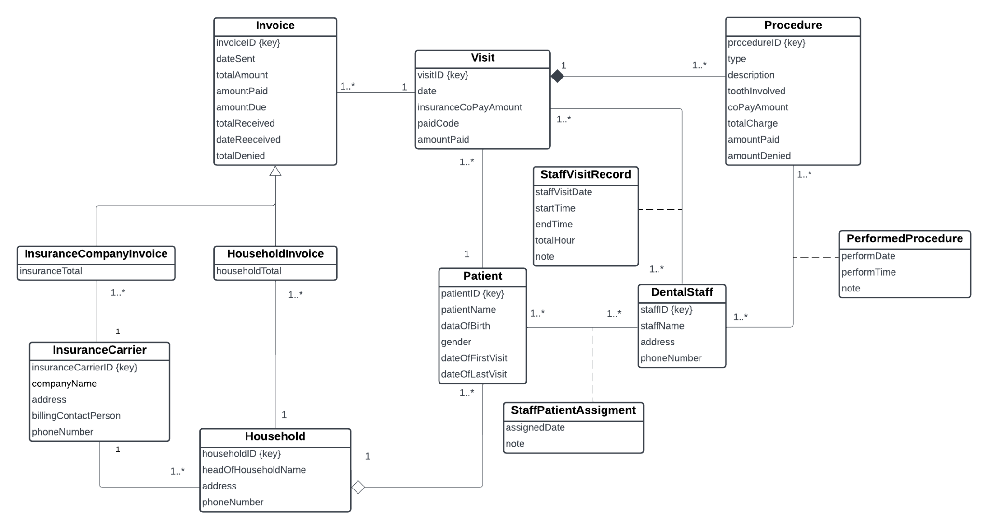

# Task B: Advanced Modelling

**Q1: State Machine Diagram**

A state machine diagram, also known as a state diagram or statechart diagram, is a type of behavioural diagram in the Unified Modeling Language (UML) that represents the various states of an object or system and the transitions between those states. It illustrates the behaviour of the system or objects over time, showing how it responds to events and changes its state based on those events. State machine diagrams are widely used in software engineering and system modelling to depict the dynamic behaviour of a system.

In the context of an insurance invoice object, a state machine diagram can be used to represent the different states the invoice object can be in and the transitions between those states. The purpose of the diagram is to provide a visual representation of the lifecycle of an insurance invoice, showcasing the possible states it can assume and how it transitions between those states based on events or actions.

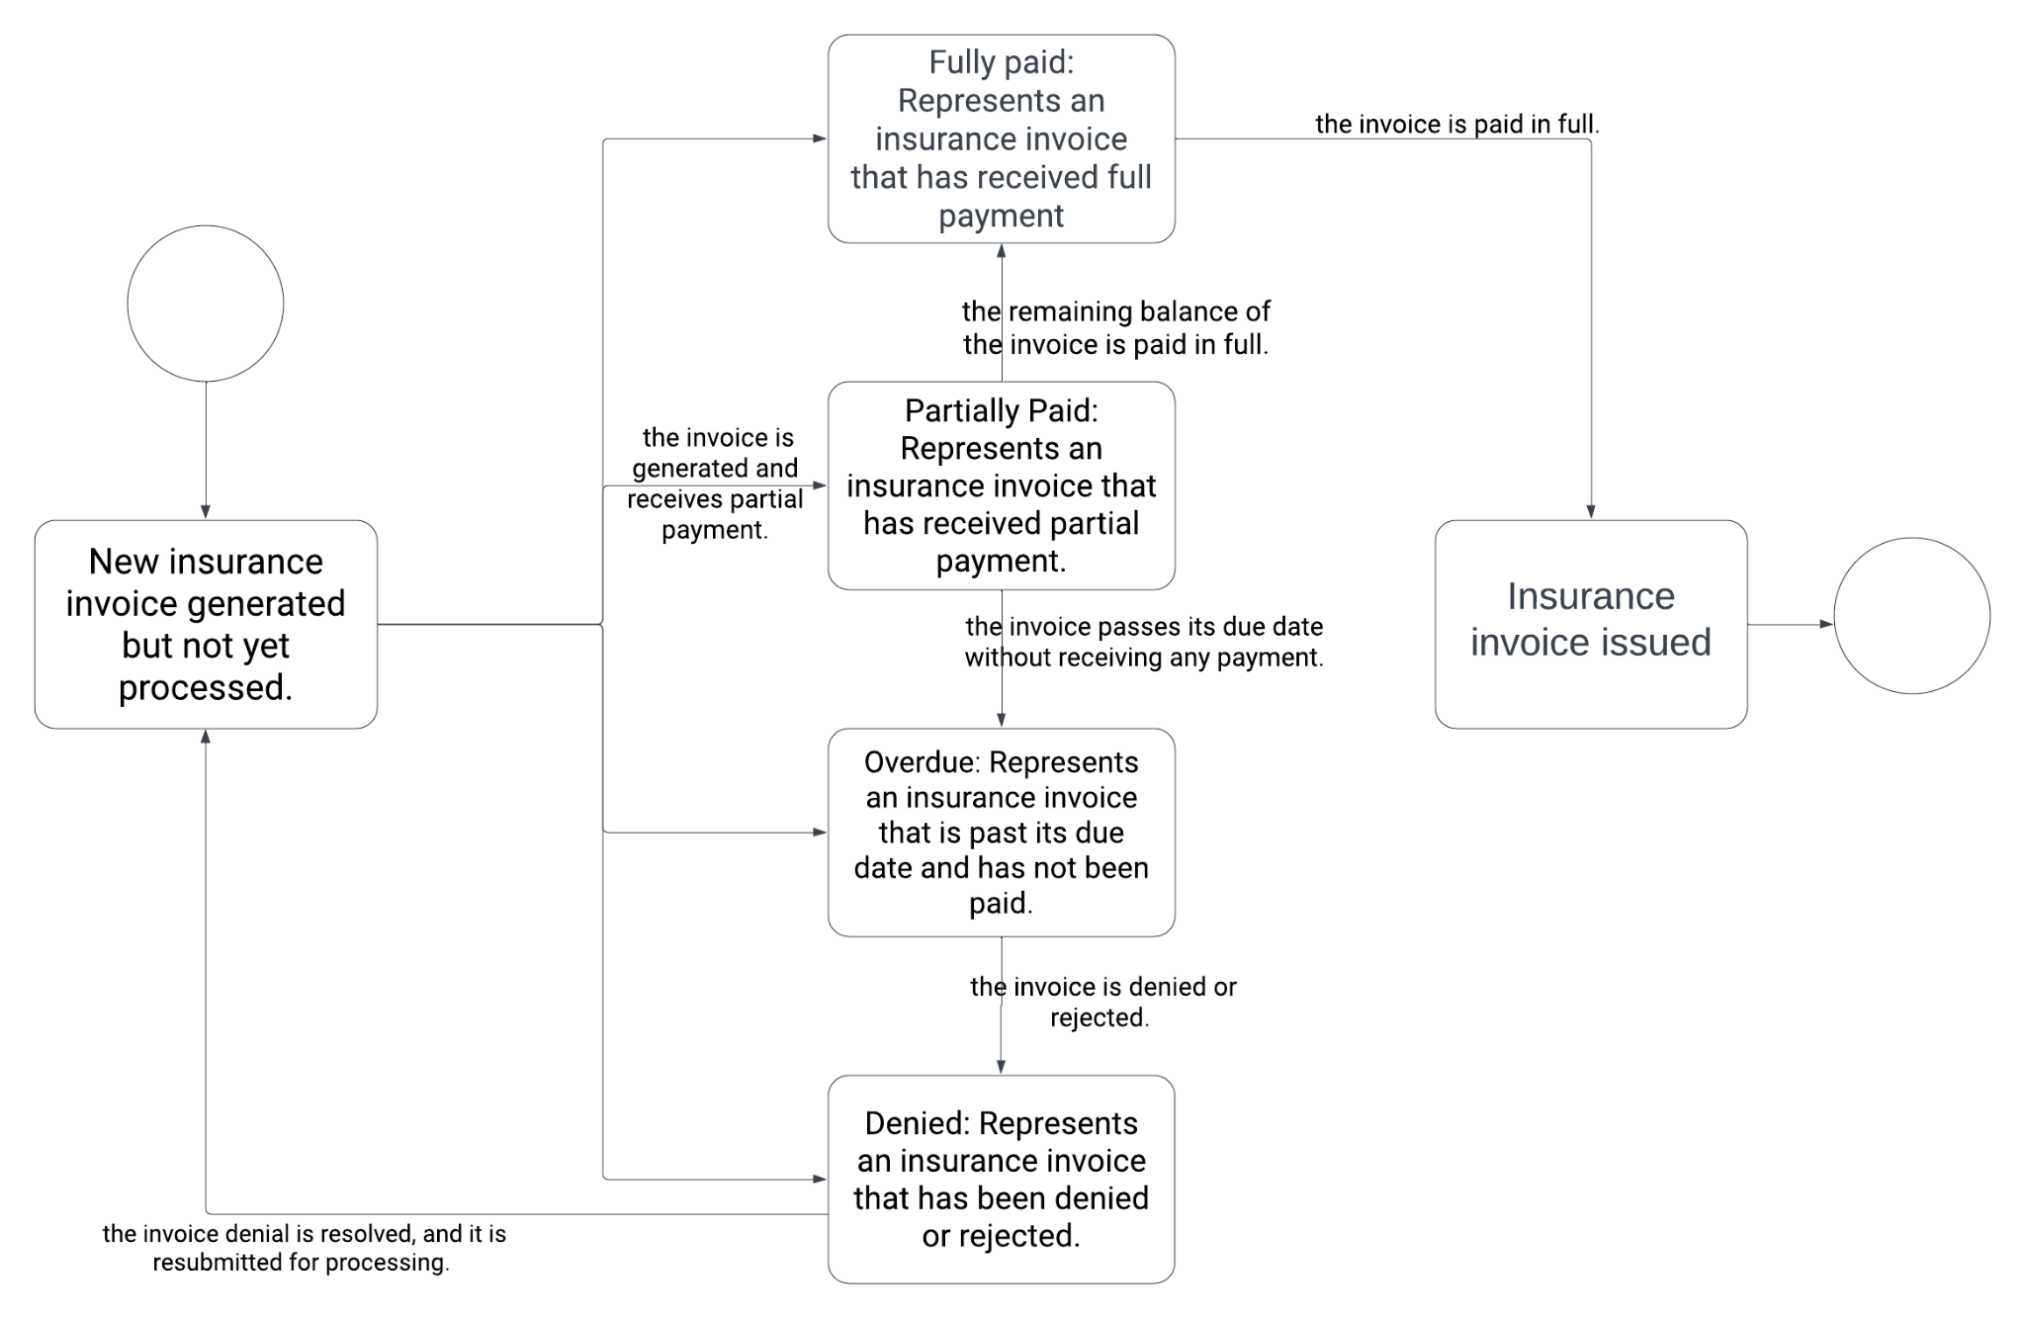

**Q2: Fully developed use case description**

|  |  |  |
| --- | --- | --- |
| **Use case name** | Record dental procedure | |
| **Scenario** | Dental staff must locate the patient and their current visit in the system and enter every step taken until it is completed. | |
| **Triggering event** | Determines the patients' information and the current visit in the system, and enter the information | |
| **Brief description** | The dental team must first locate the patient and their current visit in the system before entering the specifics of the steps taken during the procedure in the "Record Dental Procedure" use case. The procedure is repeated in a loop until it is finished, at which point the patient file is closed.. | |
| **Actors:** | Dental Staff | |
| **Related use cases:** | Access and obtain patients' information and visit information, | |
| **Stakeholders:** | Patients, Staffs, Business Manager, Owner, Insurance companies, IT team | |
| **Preconditions:** | The dental staff needs to be authorised and granted the proper access rights.  The patient must already have a record in the database.  The patient must have a current, system-recorded visit. | |
| **Postconditions:** | The patient's record is updated with the recorded procedure details.  The dental staff can access the recorded procedure details for future reference | |
| **Flow of**  **activities** | **Actor** | **System** |
| The dental staff initiates the "Record Dental Procedure" use case. | The system displays a search interface to locate the patient's record. |
| To locate the patient's record, the dental staff inserts the required search parameters (such as the patient's ID, name, or other identifiers). | The computer system locates and shows the relevant patient records. |
| From a list, the dental team chooses the right patient record. | The system verifies the patient's corresponding active visit. |
| If there are several visits, the dental staff chooses the right visit from a list or checks that it is currently active. | The system provides a form or interface where the information about the dental procedure can be entered. |
| The system shows a form or interface where the information about the dental procedure can be inputted. | The dental team records all important information about the treatment, including the steps used, the medications taken, and any issues or observations. |
| The dental staff saves a record of each procedure's specifics.. | The entered procedure information is updated in the patient's record by the system. |
| The system provides the choice of closing the patient's file or continuing to record additional procedures. | The use case resumes if the dental team chooses to record more treatments. |
| The dental team closes the patient's file after recording and verifying all the steps and procedures. | The system updates the patient's record and marks the current visit as completed. |
| **Exception conditions:** | * The dental staff may need to take appropriate action, such as getting in contact with the receptionist or making a new patient record, if the patient's file or current appointment cannot be found in the system * The dental staff can make the necessary adjustments if there are any mistakes or gaps in the details of the procedure that were recorded * The use case can be ended without closing the patient's file if the dental staff needs to stop or stop the recording of the dental procedure. * An appropriate error handling and notification system should be put in place if there are system errors or connectivity problems while the recording is being done. | |

**Q3:** **Activity Diagram**

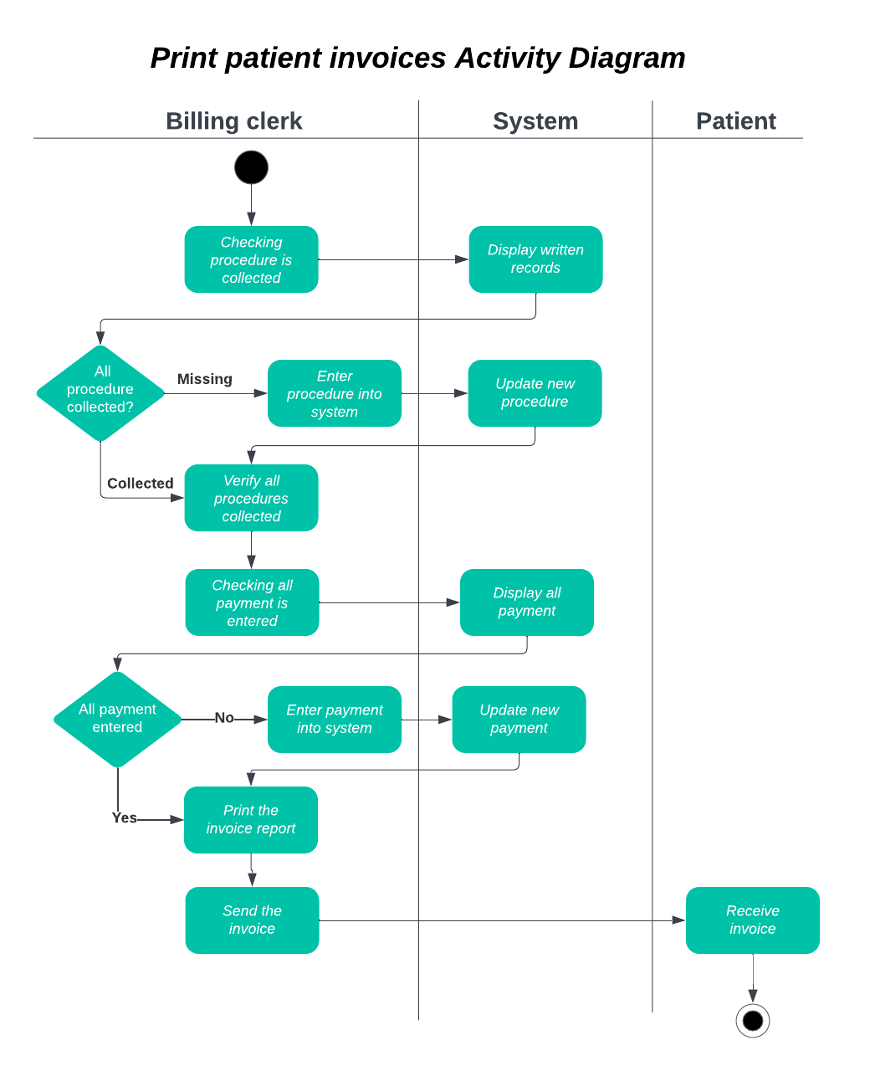

**Q4: System Sequence Diagram**

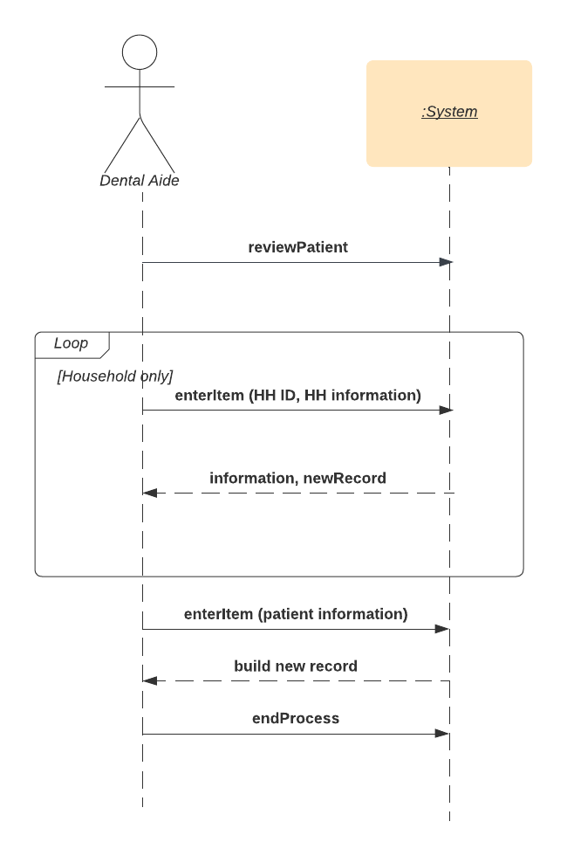

**Q5: Storyboard**

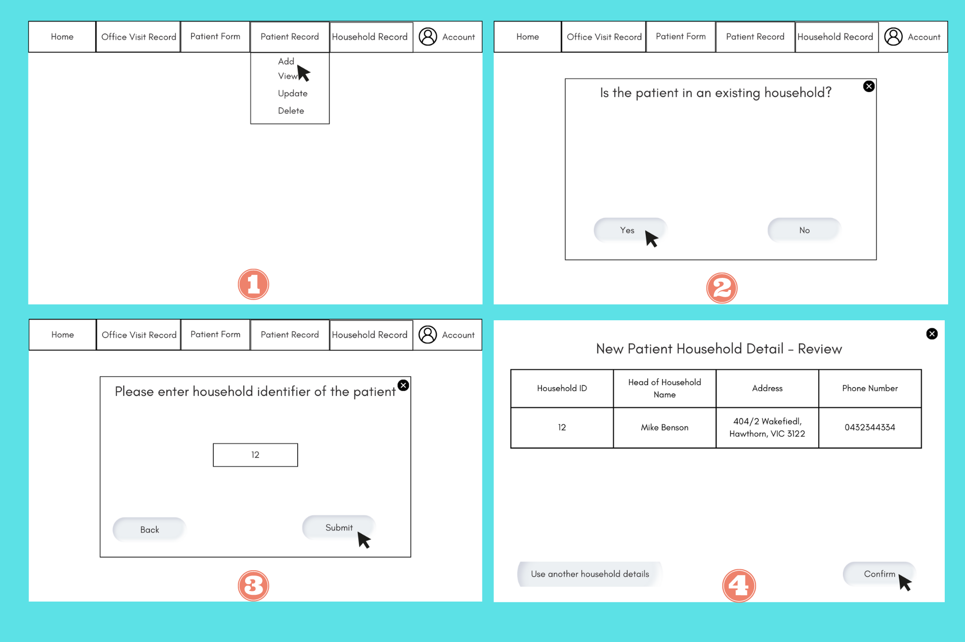

**Screen 1: Add New Patient Record Screen**

System: What would you like to do today?

Dental Aide: (After reviewing the completed patient form) I would like to add new patient record

**Screen 2: Patient in Existing Household or Not Screen**

System: So is the patient in an existing household?

Dental Aide: Yes, the patient belongs to an existing household

**Screen 3: Household Identifier Entry**

System: So if the patient is in an existing household, please enter that household identifier

Dental Aide: (Input the household identifier and click “Submit”)

System: (Prompts to move to the next screen upon clicking 'Submit')

**Screen 4: New Patient Household Detail - Review**

System: So here is the patient household detail review, you can confirm to use this household record for the new patient or you can use the other household details

Dental Aide: (Click “Confirm)

System: (Prompts to move to the next screen upon clicking 'Submit')

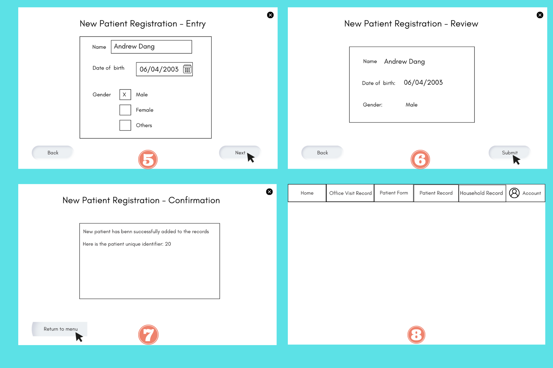

**Screen 5: New Patient Registration - Entry**

System: Please fill in the following details of the new patient

Dental Aide: (Inputs patient's name, selects date of birth using date picker, selects gender via radio buttons and click “Next”)

System: (Prompts to move to the next screen upon clicking 'Next')

**Screen 6: New Patient Registration - Review**

System: "Please review all the entered details. If everything is correct, click 'Submit'. If you need to correct something, click 'Back'."

User: (Reviews all the information and clicks 'Submit')

System: (Prompts to move to the next screen upon clicking 'Submit')

**Screen 7: New Patient Registration - Confirmation**

System: New patient has been successfully added to the records. Here is the patient unique identifier: 20

Dental Aide: (Receive the confirmation and click “Return to menu”)

System: (Prompts to move to the next screen upon clicking “Return to menu”')

**Screen 8: Menu Screen**

Dental Aide: (Come back to the main menu)

Here is the sequence of events of the use case:

1. The dental aide starts the process by selecting the option to enter a new patient's information after reviewing the patient registration form
2. The system displays the “Is patient in an existing household” screen
3. The dental aids clicks “Yes”
4. The system displays the Household Identifier Entry screen
5. The dental aide enters the household identifier and clicks the “Submit” button
6. The system displays the New Patient Household Detail Review corresponding to the household identifier
7. The dental aide clicks “Confirm”
8. The system displays the New Patient Registration - Entry screen
9. The dental aide enters the patient information and clicks “Next”
10. The system saves the information and displays the New Patient Registration - Review screen
11. The dental aide clicks “Submit”
12. The system adds a new patient record, shows the New Patient Registration - Confirmation Screen and generates an unique identifier for that patient.

**Q6: Design Principle**

My aforementioned design implements five user-interface design, which are usability, visibility, affordance, consistency and readability

**Usability**: Usability refers to the ease for users to accomplish a goal using a system. In the proposed design, usability is promoted by clearly labelling all fields, logically grouping related fields together, and guiding users through the process. The consistent use of navigation buttons ("Next", "Back", and "Cancel") across screens also helps users understand how to interact with the system. Furthermore, providing a review screen before submission allows users to verify their inputs and correct any mistakes, which enhances overall usability.

**Visibility**: Visibility is the principle of ensuring that important system elements and functions are easily visible and identifiable. In the proposed design, visibility is achieved by grouping related fields together, using descriptive labels for input fields, and using visual elements like checkboxes, radio buttons to make the user interface more intuitive. The submit button is also clearly visible at the bottom of the form, signalling the completion of the task.

**Affordance**: Affordance refers to the properties of an user interface element that indicate how it should be used. In this design, affordances are provided by using common user interface elements like text fields, date pickers, radio buttons, which users will recognize and understand how to interact with. The 'Next', 'Back', and 'Cancel' buttons also have clear affordances because their labels describe their functionalities.

**Consistency:** Consistency refers to a uniform application of design elements and standards throughout a product.The proposed design maintains consistency in the user interface, with each screen following the same layout pattern: title at the top, fields in the middle, and navigation buttons at the bottom. The same colour scheme and font are also utilised across all the screen, making the interface predictable and easier to learn, reducing the chance of errors.

**Readability**: Readability refers to making the content easy and comfortable for users to understand when they look at the screen. In the aforementioned design, readability is enhanced through the use of clear, simple language for labels and instructions. The layout of each screen also promotes readability by logically grouping related fields together and providing plenty of white space to reduce visual clutter.

# Deployment Method

**Q7: Deployment**

Considering several deployment methods in case of the Dental Clinic, suggestion is made on numerous factors such as: cost and risk associated, length of implementing and inputs required. Firstly, if the firm manages to adopt direct deployment that instantly instals a new system and makes it operational without sufficient testing and integrating system components, which can result in major risks since interruptions may occur at any time even during the services. Secondly, if the firm manages to adopt parallel deployment in which old and new systems are operating at the same extended period of time until the new system is completely installed and run through numerous testing processes; as a result, operating expenses will become a serious financial burden since resources are limited. Thus, it leads to a complicated system that is difficult to plan and manage. Considering the specific characteristics of the Dental Clinic, phased deployment would be an appropriate suggestion in terms of cost-effective and ease of operation. Phased deployment is defined as a method in which a new system will be gradually implemented step by step. From this characteristic, phased development will divide the complicated processes into smaller procedures, thus minimising the complex nature of deployment and making the system more manageable and approachable for authorised staff. Therefore, it is highly recommended for the board members of the Dental Clinic to implement phased development which fits the new systems solution.

**Q8: Recommendation**

In today’s world, information technology has been a critical factor in various industries, specifically the healthcare sector, which is directly related to the sustainable development of human beings. Thus, healthcare has been significantly transformed due to emerging and sophisticated technologies to adapt to the growing demand of external parties. However, information technology itself refers to the use of numerous systems in healthcare; for instance, telehealth, connected emergency response solutions, remote monitoring and automated healthcare. Nevertheless, in the case of the Dental Clinic System in which resources and human labour are limited, Electronic Health Record (EHR) is considered a key information technology solution which should be implemented and invested in the upcoming 5 years. Electronic Health Record (EHR) System is defined as a cost-effective system that consists of individual digital records of health-related data which can be generated directly from patients and put through an efficient analysing and managing process that will be controlled by authorised personnel in the Dental Clinic, such as dentists, business manager and the related staff within the firm. Thus, the EHR System offers Dental Clinic with diverse essential functions. Firstly, the system will start with generating and identifying issues, managing demographics, problems, and medication lists; and maintaining the recorded history of the patients. As a result, data will be further analysed and provided dentists with key care plans, guidelines, and related protocols for effective and tailored treatment for each patient. Also, detailed performance reports for each treatment will be generated frequently which helps staff keep track of patients’ situation. However, despite the extraordinary benefits of the Electronic Health Record System in the medical landscape, numerous threats and challenges should also be taken into consideration. To be more specific, as an EHR system operates on a cloud-based platform that can be accessed from multiple devices and locations, issues related to this platform such as phishing attacks, insufficient encryption, malware and ransomware could be a significant threat to the sustainable development of a business, which can cause considerable damage. In conclusion, board members of the Dental Clinic should take Electronic Health Record System as a primary investment in the upcoming 5 years, considering the outstanding advantages of this advanced technology.

# Conclusion

In conclusion, this report has provided a thorough analysis and conceptual design for a dental clinic system with an emphasis on patient administration. It highlights which stakeholders are involved, and what their interests are. As well as the effect on the system's design, and emphasises the simplification of administrative duties. The research examines the “My Health Record” system's potential integration while pointing out the difficulties with data accuracy and privacy. The system has to be able to conduct CRUD operations on various data entities due to the many use cases that have been defined. The state machine diagram for the insurance invoice object, the domain model UML Class Diagram, and the activity diagram illustrate the system's structure and functionality. The proposed storyboard for the "Enter new patient" scenario incorporates design principles to enhance usability . Overall, this study provides an in-depth path for the development of the Dental Clinic System, with further research concentrated on resolving shortcomings and getting the system ready for actual deployment.

# Reference

Health Direct. (2019, August 22). *About My Health Record*. Healthdirect.gov.au; Healthdirect Australia.<https://www.healthdirect.gov.au/my-health-record>

Margo, J. (2018, July 17). *My Health Record: the benefits and risks explained*. Australian Financial Review.<https://www.afr.com/life-and-luxury/health-and-wellness/my-health-record-the-benefits-and-risks-explained-20180716-h12rk5>

Journal, H. (2022, October 14). *Editorial: Why Do Criminals Target Medical Records*. HIPAA Journal.<https://www.hipaajournal.com/why-do-criminals-target-medical-records/#:~:text=Healthcare%20records%20are%20so%20valuable>

Kost, E. (2023). 14 Biggest Healthcare Data Breaches [Updated 2023] [Review of 14 Biggest Healthcare Data Breaches [Updated 2023]]. UpGuard.<https://www.upguard.com/blog/biggest-data-breaches-in-healthcare#toc-0>

Wuerdeman, L., Volk, L., Pizziferri, L., Tsurikova, R., Harris, C., Feygin, R., Epstein, M., Meyers, K., Wald, J. S., Lansky, D., & Bates, D. W. (2005). How accurate is information that patients contribute to their Electronic Health Record? *AMIA ... Annual Symposium Proceedings. AMIA Symposium*, *2005*, 834–838.<https://www.ncbi.nlm.nih.gov/pmc/articles/PMC1560697/#:~:text=However%2C%20whenever%20there%20were%20valid>

Liaw, S.-T., & John Stirling Humphreys. (2006). Rural eHealth paradox: It’s not just geography! *Australian Journal of Rural Health*, *14*(3), 95–98.<https://doi.org/10.1111/j.1440-1584.2006.00786.x>

Aeologic. (2022, August 8). The Importance of Information Technology in Healthcare. Aeologic Blog. https://www.aeologic.com/blog/the-importance-of-information-technology-in-healthcare/

HHS. (2020). Electronic Health Record Systems. https://www.hhs.gov/sites/default/files/electronic-health-record-systems.pdf

worldwideservices. (2019, October 18). Role of IT in Healthcare | How is IT Used in Healthcare? Worldwide Services. https://worldwideservices.net/the-role-of-information-technology-services-in-healthcare/